**Microprocessor and Computer Architecture**

**UE20CS252**

**4th Semester, Academic Year 2021-22**

Date: 24/1/2022

|  |  |  |
| --- | --- | --- |
| Name:  P K Navin Shrinivas | SRN: PES2UG20CS237 | Section:  D |

Week#____2_______ Program Number: ____1___

Title of the Program

**Write an ALP using ARM instruction set to check if a number stored in a register is even or odd. If even, store 00 in R0, else store FF in R0**

1. ARM Assembly Code(1)

mov r1,#9

ands r2,r1,#1

beq even

mov r0,#0xff

b odd

even : mov r0,#0x00

odd : swi 0x011

1. Output Screen Shot (1)

The output should be verified for both even and odd numbers.

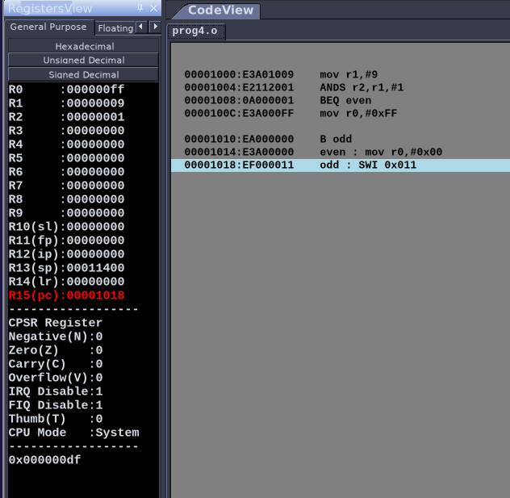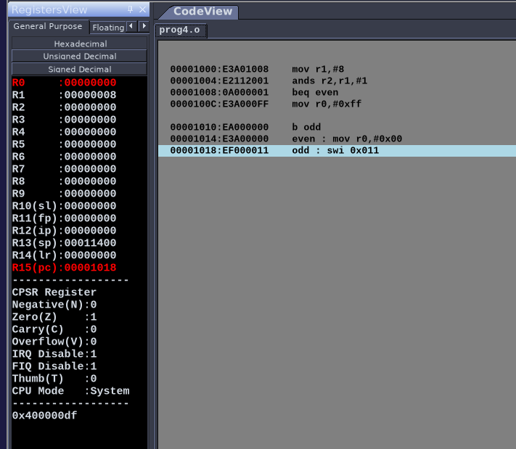

1. **Output table (1)**

**Included in screenshots above**

**Microprocessor and Computer Architecture**

**UE20CS253**

**4th Semester, Academic Year 2021-22**

Date:

|  |  |  |
| --- | --- | --- |
| Name:  P K Navin Shrinivas | SRN:PES2UG20CS237 | Section :  D |

Week#____1_______ Program Number: ____2___

Title of the Program

**Write an ALP to compare the value of R0 and R1, add if R0 = R1, else subtract**

**1.ARM Assembly Code(1)**

mov r0,#10

mov r1,#10

CMP r0,r1

BEQ equal

B notequal

notequal :

SUB r3,r0,r1

B end

equal :

ADD r3,r0,r1

B end

end : .end

2.Output Screen Shot (1)

Considering both equal and not equal:

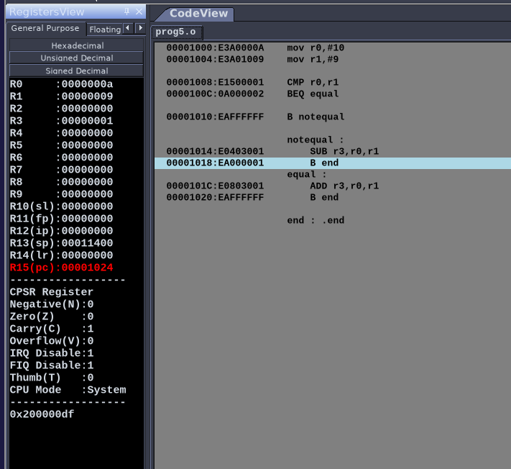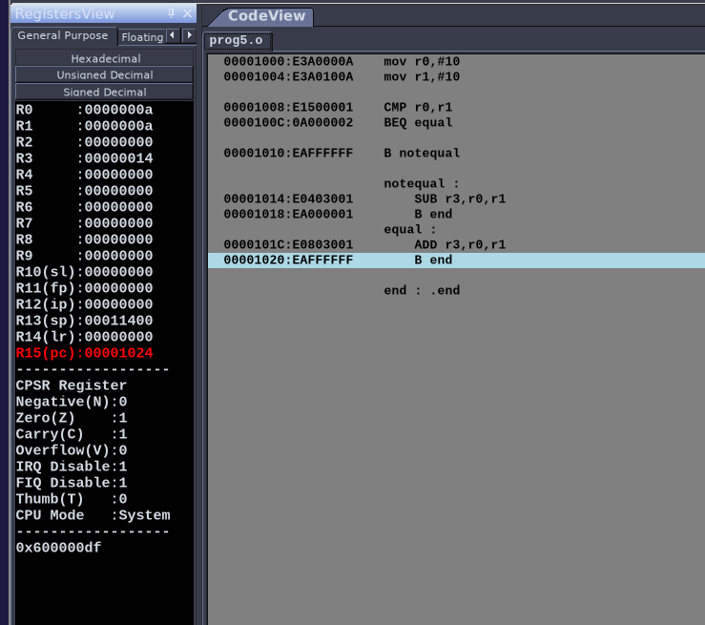

**Disclaimer:**

* The programs and output submitted is duly written, verified and executed by me.
* I have not copied from any of my peers nor from the external resource such as internet.
* If found plagiarized, I will abide with the disciplinary action of the University.

Signature:P K Navin Shrinivas

Name:P K Navin Shrinivas

SRN:PES2UG20CS237

Section: D

Date:24/01/2022